Plasmit Hospital Management System
High-Level Database Contract, Table Relationship Blueprint & FHIR Mapping

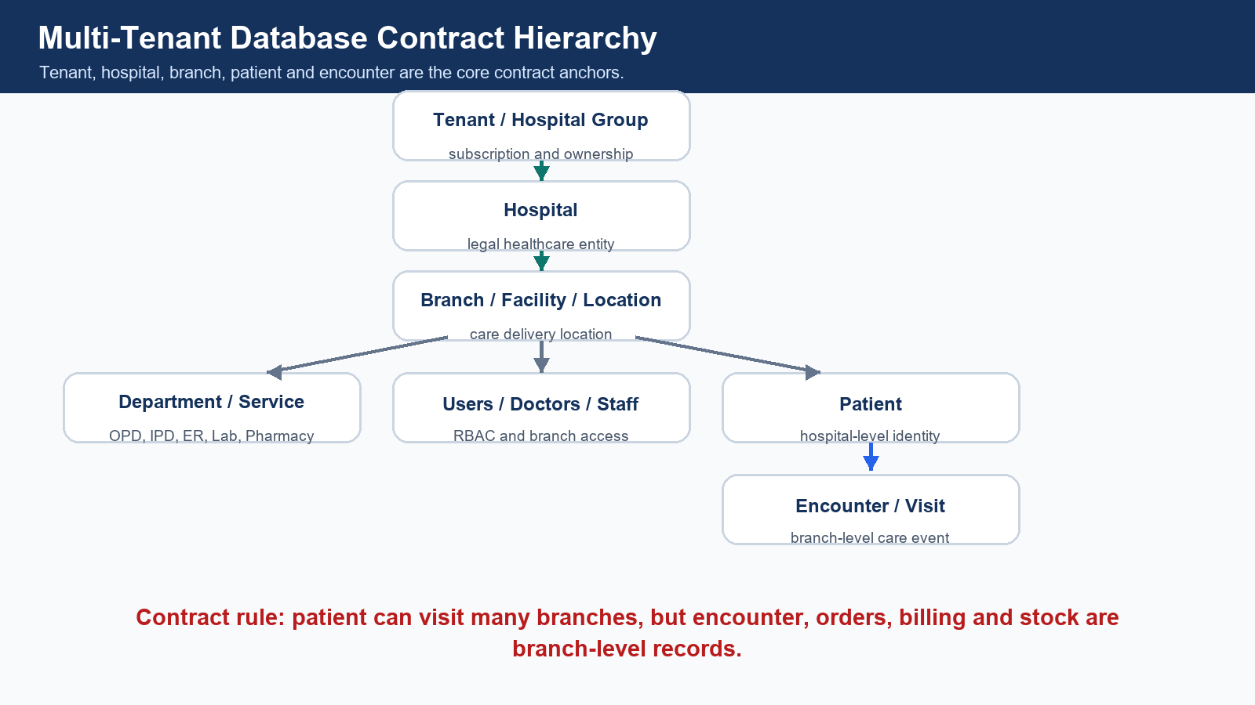
Database contract hierarchy for tenant, hospital, branch, patient and encounter.
Item | Details
Project | Plasmit Global Hospital Management System
Document | High-Level Database Contract & FHIR Mapping Blueprint
Version | 1.0
Prepared For | Engineering, Architecture, QA, Integration and Product Teams
Prepared By | Plasmit Engineering Team
Technology | Spring Boot microservices, Java 17, MySQL, JDBC/NamedParameterJdbcTemplate, Flyway

Table of Contents
- 1. Executive Summary
- 2. Core Database Contract Principles
- 3. Recommended Multi-Tenant Hierarchy
- 4. Core Foundation Tables and Relationships
- 5. Patient-Centric Tables and Relationships
- 6. Appointment Tables and Relationships
- 7. Encounter-Centric Clinical Model
- 8. Prescription and Medication Tables
- 9. Lab / Diagnostics Tables and Relationships
- 10. Radiology Tables and Relationships
- 11. Pharmacy and Inventory Tables
- 12. Billing, Payment and Insurance Tables
- 13. IPD, Ward, Room and Bed Tables
- 14. Surgery / OT Tables
- 15. Documents and Reports
- 16. Audit and Compliance Tables
- 17. FHIR Integration Tables
- 18. HL7 Integration Tables
- 19. Reporting and Denormalized Tables
- 20. Master Table Contract
- 21. Complete Table Relationship Matrix
- 22. Module Ownership Matrix
- 23. Foreign Key Contract Rules
- 24. Tenant Isolation and Query Contract
- 25. Indexing, Migration and API Impact Contract
- 26. Mermaid ERD Visual Contract
- 27. Developer Agreement Checklist
- 28. Final Database Contract Summary

1. Executive Summary
This document is the formal high-level database contract for the Plasmit Global Hospital Management System. It defines the agreed tables, table relationships, ownership boundaries, tenant isolation rules, FHIR/HL7 mapping responsibilities, migration rules and API query rules that every developer must follow.
Contract purpose
- Create a fixed agreement before parallel backend development starts.
- Prevent duplicate tables, inconsistent naming and broken relationships.
- Protect tenant, hospital and branch data isolation.
- Ensure patient, encounter, lab, pharmacy, billing and document records are FHIR-ready.
- Ensure HL7 inbound/outbound messages are logged and traceable.
- Make Flyway migrations and review workflows mandatory.

2. Core Database Contract Principles
- Every major table must include tenant_id and hospital_id.
- Every branch-level operational table must include branch_id.
- Patient should be hospital-level by default.
- Encounter should be branch-level.
- Billing, lab, pharmacy, appointment, bed, ward and stock records should be branch-level.
- No table should be created without ownership.
- No duplicate table should be created for the same business entity.
- No backend query should fetch data without tenant/hospital/branch filters.
- All schema changes must use Flyway migration.
- Old merged migration files must never be edited.
- Every table must have audit columns.
- Every critical action must create audit log.
- FHIR mapping must be documented for clinical, patient, billing, lab, pharmacy and document modules.
- HL7 inbound/outbound messages must be logged.
- Reporting tables must not replace transactional normalized tables.

3. Recommended Multi-Tenant Hierarchy

Tenant to FHIR mapping hierarchy.
graph TD
A[Tenant / Hospital Group] --> B[Hospital]
B --> C[Branch / Facility / Location]
C --> D[Department / Healthcare Service]
C --> E[Users / Doctors / Staff]
B --> F[Patient]
F --> G[Encounter / Visit]
G --> H[Clinical Records]
G --> I[Lab Orders & Results]
G --> J[Radiology Orders & Reports]
G --> K[Prescription]
K --> L[Pharmacy Dispensing]
G --> M[Billing & Payment]
G --> N[Documents]
H --> O[FHIR Mapping Layer]
I --> O
J --> O
K --> O
M --> O
N --> O

4. Core Foundation Tables and Relationships
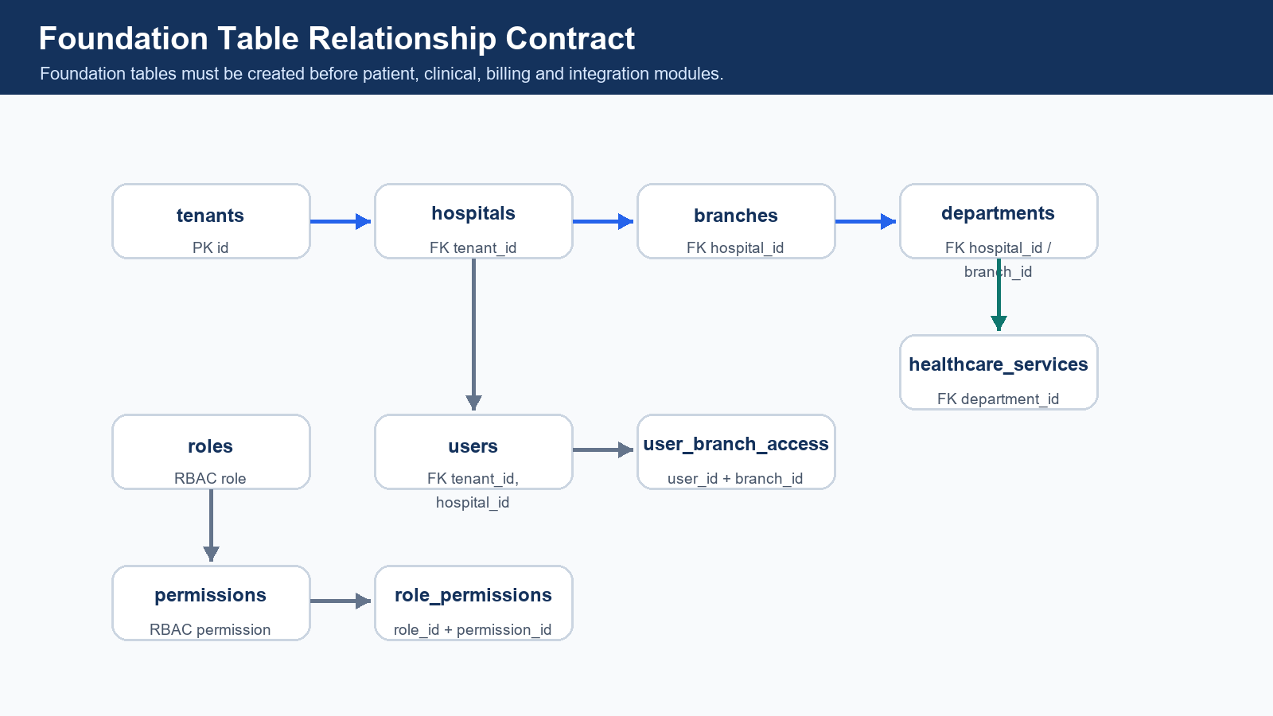
Foundation relationship contract.
Parent Table | Child Table | Relationship | Join Key | Business Meaning | FHIR Mapping
tenants | hospitals | 1:N | hospitals.tenant_id | One tenant can own many hospitals. | Organization
hospitals | branches | 1:N | branches.hospital_id | One hospital can have many branches/facilities. | Location
hospitals | departments | 1:N | departments.hospital_id | Hospital defines departments. | HealthcareService
branches | departments | 1:N optional | departments.branch_id | Branch-specific departments when required. | HealthcareService
departments | healthcare_services | 1:N | healthcare_services.department_id | Department provides services. | HealthcareService
users | user_branch_access | 1:N | user_branch_access.user_id | User can access multiple authorized branches. | PractitionerRole
branches | user_branch_access | 1:N | user_branch_access.branch_id | Branch access is explicitly assigned. | Location
roles | role_permissions | 1:N | role_permissions.role_id | Role receives permissions. | N/A
permissions | role_permissions | 1:N | role_permissions.permission_id | Permission can be part of many roles. | N/A

5. Patient-Centric Tables and Relationships
Patient is hospital-level by default. A patient can visit multiple branches under the same hospital. Branch-specific activity begins from appointment and encounter.
Table | Relationship Contract | FHIR Mapping
patients | hospitals 1:N patients | Patient
patient_identifiers | patients 1:N identifiers | Patient.identifier
patient_addresses | patients 1:N addresses | Patient.address
patient_contacts | patients 1:N contacts | Patient.contact / RelatedPerson
patient_allergies | patients 1:N allergies | AllergyIntolerance
patient_insurance | patients 1:N insurance policies | Coverage
patient_documents | patients 1:N documents | DocumentReference
patient_consent_records | patients 1:N consent records | Consent
patient_record_access_logs | patients 1:N access logs | AuditEvent

6. Appointment Tables and Relationships
Table | Primary Relationship | FHIR Mapping
appointment_slots | branches/doctors 1:N slots | Schedule / Slot if required
appointments | patients, branches and doctors 1:N appointments | Appointment
appointment_status_history | appointments 1:N status history | AuditEvent / Provenance
appointment_reminders | appointments 1:N reminders | Communication
appointment_cancellations | appointments 0/1 cancellation record | Appointment.status / AuditEvent

7. Encounter-Centric Clinical Model
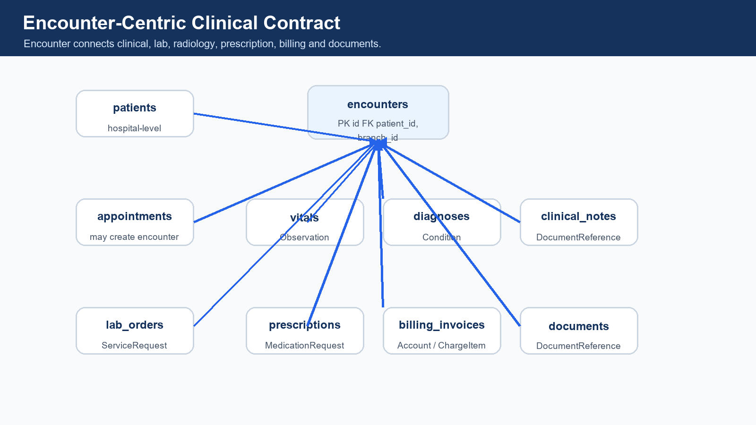
Encounter-centric relationship model.
Table | Relationship Contract | FHIR Mapping
encounters | patients 1:N encounters; branches 1:N encounters; appointment 0/1:1 encounter | Encounter
encounter_participants | encounters 1:N participants; users/practitioners N:1 | Encounter.participant / PractitionerRole
encounter_status_history | encounters 1:N status events | Provenance / AuditEvent
vitals | encounters 1:N vitals | Observation
diagnoses | encounters 1:N diagnoses | Condition
clinical_notes | encounters 1:N clinical notes | DocumentReference / Composition
clinical_documents | encounters 1:N clinical documents | DocumentReference
procedures | encounters 1:N procedures | Procedure
care_plans | encounters 1:N care plans | CarePlan

graph TD
A[Patient] --> B[Encounter]
C[Branch / Location] --> B
D[Doctor / Practitioner] --> E[Encounter Participants]
B --> E
B --> F[Vitals / Observations]
B --> G[Diagnoses / Conditions]
B --> H[Clinical Notes]
B --> I[Procedures]
B --> J[Care Plans]
B --> K[Documents]
B --> L[Lab Orders]
B --> M[Prescription]
B --> N[Billing Invoice]

8. Prescription and Medication Tables
Table | Relationship Contract | FHIR Mapping
prescriptions | encounters 1:N prescriptions | MedicationRequest
prescription_items | prescriptions 1:N items; medicine_master N:1 | MedicationRequest.dosageInstruction
medicine_master | medicine catalog used by prescription and pharmacy | Medication
medication_instructions | prescription_items 1:N reusable instructions | MedicationRequest.dosageInstruction
medication_administration_records | inpatient medication administration events | MedicationAdministration
pharmacy_dispense | prescriptions 1:N dispense events | MedicationDispense
pharmacy_dispense_items | dispense event 1:N batch/medicine items | MedicationDispense

9. Lab / Diagnostics Tables and Relationships
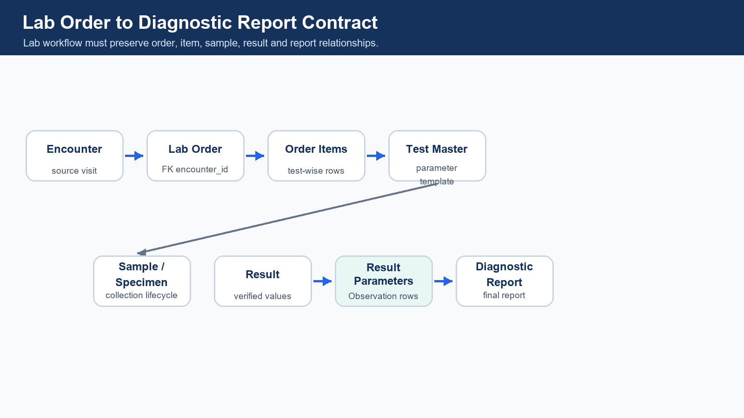
Lab order to report relationship contract.
Table | Relationship Contract | FHIR Mapping
lab_test_master | Master catalog for lab tests | ObservationDefinition / Code mapping
lab_test_parameters | lab_test_master 1:N parameters | Observation.component
lab_orders | encounters 1:N lab orders | ServiceRequest
lab_order_items | lab_orders 1:N items; lab_test_master N:1 | ServiceRequest
lab_samples | lab_order_items 1:N samples | Specimen
lab_results | lab_order_items 1:N results | Observation
lab_result_parameters | lab_results 1:N result values | Observation.component
diagnostic_reports | lab_results may generate reports | DiagnosticReport
lab_result_review_history | lab_results 1:N reviews | Provenance / AuditEvent

graph LR
A[Encounter] --> B[Lab Order]
B --> C[Lab Order Items]
C --> D[Test Master]
D --> E[Test Parameters]
C --> F[Sample / Specimen]
C --> G[Result]
G --> H[Result Parameters / Observations]
G --> I[Diagnostic Report]

10. Radiology Tables and Relationships
Table | Relationship Contract | FHIR Mapping
radiology_test_master | Radiology/imaging test catalog | ServiceRequest code
radiology_orders | encounters 1:N radiology orders | ServiceRequest
radiology_order_items | radiology_orders 1:N order items | ServiceRequest
radiology_reports | radiology_order_items generate reports | DiagnosticReport
imaging_studies | radiology_reports may connect to imaging studies | ImagingStudy
radiology_report_review_history | radiology_reports 1:N reviews | Provenance / AuditEvent

11. Pharmacy and Inventory Tables
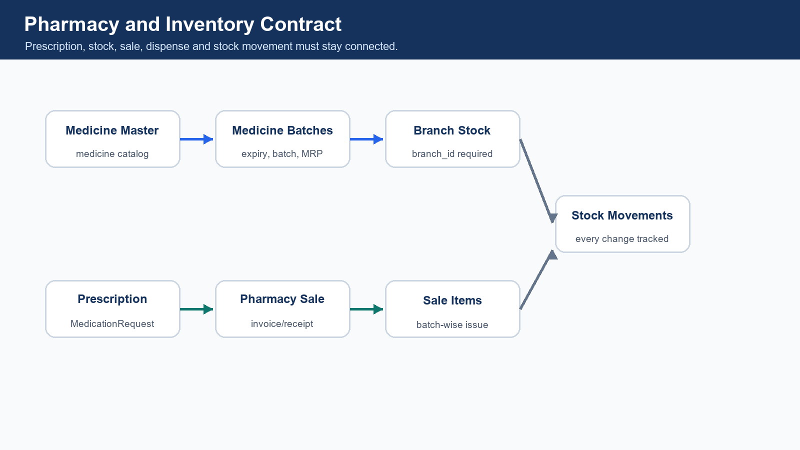
Pharmacy, batch, stock and dispensing relationship contract.
Table | Relationship Contract | FHIR Mapping
medicine_master | Master medicine catalog | Medication
medicine_categories | medicine grouping | Internal
medicine_batches | medicine_master 1:N batches | Medication.batch
pharmacy_stock | branches 1:N stock; batches 1:N stock rows | Internal
stock_movements | tracks every stock change | Internal
pharmacy_sales | prescription may connect to pharmacy sale | MedicationDispense
pharmacy_sale_items | pharmacy_sales 1:N sale items; batches N:1 | MedicationDispense
pharmacy_returns | sales 1:N return events | Internal
purchase_orders / goods_receipts | procurement creates stock source | Internal

12. Billing, Payment and Insurance Tables
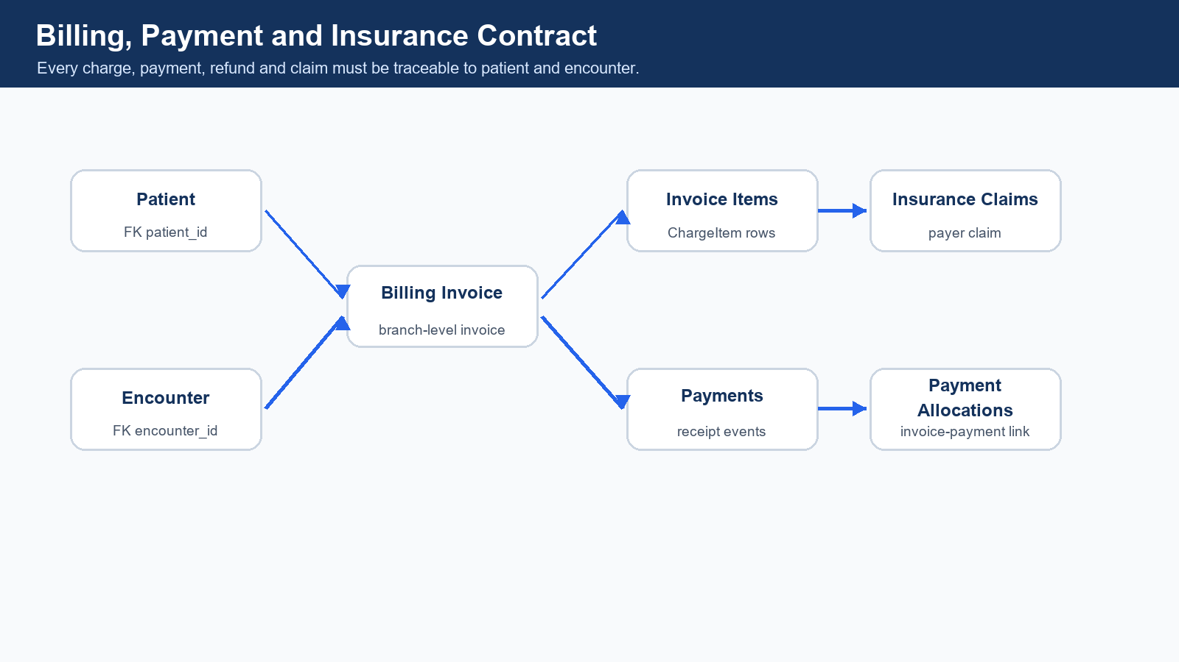
Billing, payment and insurance relationship contract.
Table | Relationship Contract | FHIR Mapping
billing_invoices | patients and encounters 1:N invoices | Account
billing_invoice_items | billing_invoices 1:N charge items | ChargeItem
payments | payment events | PaymentReconciliation if required
payment_allocations | billing_invoices and payments N:M link | ExplanationOfBenefit if required
refunds | billing_invoices 1:N refunds | Internal / PaymentReconciliation
insurance_policies | patients 1:N policies | Coverage
insurance_claims | billing_invoices may connect to claims | Claim
insurance_claim_items | claims 1:N claim items | Claim.item
claim_documents | claims 1:N documents | DocumentReference
claim_status_history | claims 1:N status events | Provenance / ExplanationOfBenefit

13. IPD, Ward, Room and Bed Tables
Table | Relationship Contract | FHIR Mapping
admissions | encounters may create admissions | Encounter
wards | branches 1:N wards | Location
rooms | wards 1:N rooms | Location
beds | rooms 1:N beds | Location
bed_allocations | admissions 1:N bed allocations | Encounter.location
nursing_notes | admissions 1:N nursing notes | DocumentReference
nursing_tasks | admissions 1:N nursing tasks | Task
discharge_plans | admissions 1:N plans | CarePlan
discharge_summaries | admissions 1:N summaries | Composition + DocumentReference

14. Surgery / OT Tables
Table | Relationship Contract | FHIR Mapping
operation_theatres | branches 1:N operation theatres | Location
surgery_cases | encounters 1:N surgery cases | Procedure
surgery_team_members | surgery_cases 1:N team members | PractitionerRole
surgery_checklists | surgery_cases 1:N checklist records | QuestionnaireResponse if required
anesthesia_records | surgery_cases 1:N anesthesia records | Observation
surgery_notes | surgery_cases 1:N notes | DocumentReference
post_operation_notes | surgery_cases 1:N post-op notes | DocumentReference

15. Documents and Reports
Table | Relationship Contract | FHIR Mapping
documents | patients/encounters 1:N documents | DocumentReference
document_versions | documents 1:N versions | DocumentReference.version
document_access_logs | documents 1:N access logs | AuditEvent
document_signatures | documents 1:N signatures | Provenance / DocumentReference

16. Audit and Compliance Tables
Table | Relationship Contract | FHIR Mapping
audit_logs | every critical module writes audit logs | AuditEvent
user_login_history | users 1:N login records | AuditEvent
patient_record_access_logs | patients 1:N access logs | AuditEvent
consent_records | patients 1:N consent records | Consent
break_glass_access_logs | emergency access log | AuditEvent
data_export_logs | patient data export trace | AuditEvent / Provenance

17. FHIR Integration Tables
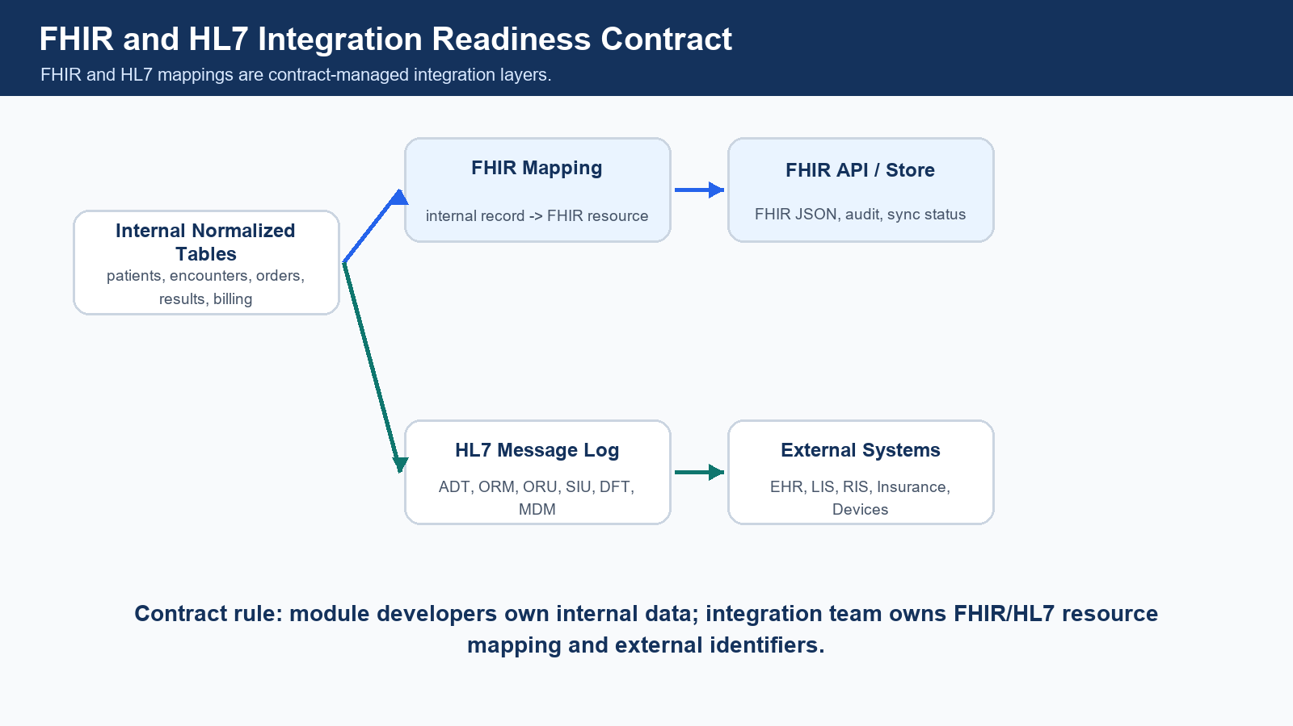
FHIR and HL7 integration readiness contract.
FHIR Table | Purpose | Key Columns
fhir_resource_mapping | Connect internal table records to FHIR resource IDs. | id, tenant_id, hospital_id, branch_id, internal_table_name, internal_record_id, fhir_resource_type, fhir_resource_id, fhir_version, profile_url, sync_status
fhir_resource_store | Store generated or received FHIR JSON when required. | id, mapping_id, resource_type, resource_id, resource_json, version, status
fhir_api_audit_log | Track every FHIR API call. | id, tenant_id, hospital_id, request_method, resource_type, status_code, performed_by
fhir_sync_status | Track sync with external systems. | id, mapping_id, target_system, sync_status, last_synced_at
fhir_profile_registry | Register supported FHIR profiles. | id, profile_url, resource_type, version, status
fhir_code_system_mapping | Map internal codes to SNOMED, LOINC, ICD, RxNorm. | id, internal_code, standard_system, standard_code
fhir_value_set_mapping | Manage allowed FHIR values. | id, value_set_url, internal_value, fhir_value

HMS Concept | Internal Tables | FHIR Resource | Integration Purpose | Owner
Tenant / Hospital | tenants, hospitals | Organization | Represent organization, tenant group or hospital. | FHIR Team + Foundation
Branch / Facility | branches | Location | Represent facility, branch, ward, room or bed. | FHIR Team + Foundation
Department / Service | departments, healthcare_services | HealthcareService | Expose healthcare service catalog. | FHIR Team + Foundation
Doctor / Staff | users, practitioner_roles | Practitioner, PractitionerRole | Expose clinician and role context. | FHIR Team + Security
Patient | patients, patient_identifiers, patient_addresses, patient_contacts | Patient | Expose patient demographics and identifiers. | FHIR Team + Patient
Consent | patient_consent_records, consent_records | Consent | Consent tracking and data sharing permission. | FHIR Team + Compliance
Appointment | appointments | Appointment | Appointment scheduling and participants. | FHIR Team + Appointment
Encounter | encounters | Encounter | OPD, IPD, ER, day-care or virtual visit. | FHIR Team + Clinical
Vitals / Lab Values | vitals, lab_results, lab_result_parameters | Observation | Clinical measurements and lab values. | FHIR Team + Clinical/Lab
Diagnosis | diagnoses | Condition | Diagnosis/problem list. | FHIR Team + Clinical
Clinical Documents | clinical_notes, documents | DocumentReference, Composition | Clinical notes, summaries and signed documents. | FHIR Team + Documents
Procedure / Surgery | procedures, surgery_cases | Procedure | Procedure and surgery representation. | FHIR Team + Surgery
Care Plan | care_plans | CarePlan | Patient care planning. | FHIR Team + Clinical
Prescription | prescriptions, prescription_items | MedicationRequest | Medication orders. | FHIR Team + Clinical/Pharmacy
Medicine | medicine_master | Medication | Medicine catalog/reference. | FHIR Team + Pharmacy
Dispensing | pharmacy_dispense, pharmacy_sales | MedicationDispense | Dispensed medications. | FHIR Team + Pharmacy
Medication Admin | medication_administration_records | MedicationAdministration | Inpatient medicine administration. | FHIR Team + Nursing
Lab/Radiology Order | lab_orders, radiology_orders | ServiceRequest | Diagnostic, procedure and imaging orders. | FHIR Team + Lab/Radiology
Sample | lab_samples | Specimen | Lab specimen lifecycle. | FHIR Team + Lab
Diagnostic Report | diagnostic_reports, radiology_reports | DiagnosticReport | Lab/radiology report. | FHIR Team + Diagnostics
Imaging | imaging_studies | ImagingStudy | Imaging study references. | FHIR Team + Radiology
Billing Account | billing_invoices, patient_accounts | Account | Billing account context. | FHIR Team + Billing
Charges | billing_invoice_items | ChargeItem | Charge line items. | FHIR Team + Billing
Insurance | insurance_policies | Coverage | Insurance policy coverage. | FHIR Team + Billing
Claim | insurance_claims | Claim | Insurance claim submission. | FHIR Team + Billing
Payment Explanation | claim_status_history, payment_allocations | ExplanationOfBenefit | Claim/payment explanation when required. | FHIR Team + Billing
Audit | audit_logs | AuditEvent | Security and data access audit. | FHIR Team + Audit

18. HL7 Integration Tables
HL7 Table | Purpose
hl7_message_log | Store inbound/outbound raw HL7 message, direction, type, status and processing trace.
hl7_message_error_log | Store parse, validation and mapping errors.
hl7_external_identifier_mapping | Map external system identifiers to internal records.
hl7_patient_mapping | External patient ID to internal patient ID.
hl7_order_mapping | External order ID to internal lab/radiology order.
hl7_result_mapping | External result ID to internal observation/result.

HL7 Message Type | Purpose
ADT | Admission, discharge and transfer messages.
ORM | Order messages, commonly lab/radiology orders.
ORU | Observation/result messages.
SIU | Scheduling messages.
DFT | Financial transaction messages.
MDM | Medical document management messages.

19. Reporting and Denormalized Tables
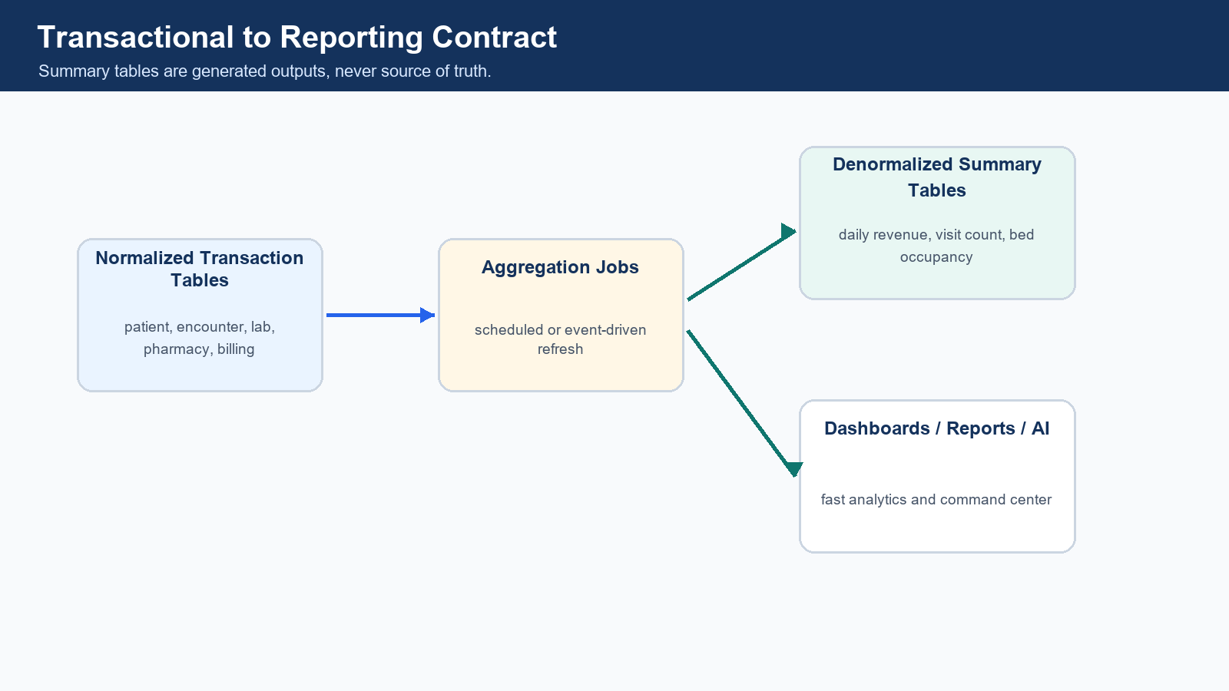
Transactional to denormalized reporting contract.
Summary Table | Source Tables | Purpose
daily_branch_revenue_summary | billing_invoices, payments | Branch revenue dashboard.
daily_patient_visit_summary | appointments, encounters | Visit volume dashboard.
doctor_performance_summary | encounters, orders, billing | Doctor productivity analytics.
department_collection_summary | billing_invoice_items, departments | Department revenue tracking.
lab_test_volume_summary | lab_orders, lab_results | Lab workload analytics.
pharmacy_stock_snapshot | pharmacy_stock, stock_movements | Stock and expiry dashboard.
bed_occupancy_summary | admissions, beds, bed_allocations | IPD occupancy dashboard.
patient_journey_summary | encounter, lab, pharmacy, billing, discharge | AI command center and operational tracking.

graph LR
A[Transactional Tables] --> B[Aggregation Job]
B --> C[Summary Tables]
C --> D[Dashboard]
C --> E[Reports]
C --> F[AI Command Center]

20. Master Table Contract
Master Type | Examples | Scope Rule
Global standard masters | gender_master, blood_group_master, country_master, state_master, city_master | No hospital_id unless customization is required.
Workflow masters | encounter_type_master, appointment_status_master, invoice_status_master, payment_mode_master | Global or tenant-level depending on product design.
FHIR/HL7 masters | fhir_resource_type_master, hl7_message_type_master | Global standard masters.
Clinical code masters | diagnosis_code_master, loinc_code_master, snomed_code_master, icd10_code_master, rxnorm_code_master | Global standard, with hospital extension table if customized.
Hospital-specific masters | service_catalog, charge_master, medicine_master | Must include tenant_id and hospital_id.
Branch-specific masters | counters, rooms, beds, pharmacy_stock | Must include tenant_id, hospital_id and branch_id.

21. Complete Table Relationship Matrix
Module | Table Name | Primary Key | Foreign Keys | Connected Parent Table | Connected Child Table | Relationship Type | Tenant Scope | Branch Scope | FHIR Resource | Owner Team
Foundation | tenants | id | None | None | hospitals | 1:N | Global/Tenant | No | Organization | Foundation Team
Foundation | hospitals | id | tenant_id | tenants | branches, departments, patients | 1:N | Tenant | No | Organization | Foundation Team
Foundation | branches | id | tenant_id, hospital_id | hospitals | appointments, encounters, pharmacy_stock | 1:N | Hospital | Yes | Location | Foundation Team
Foundation | users | id | tenant_id, hospital_id | hospitals | appointments, encounters, audit_logs | 1:N | Hospital | Optional | Practitioner | Foundation Team
Patient | patients | id | tenant_id, hospital_id | hospitals | encounters, appointments, documents | 1:N | Hospital | No by default | Patient | Patient Team
Patient | patient_identifiers | id | patient_id | patients | None | N:1 | Hospital | No | Patient.identifier | Patient Team
Appointment | appointments | id | patient_id, branch_id, doctor_id | patients, branches, users | encounters, reminders | N:1 / 1:N | Hospital | Yes | Appointment | Appointment Team
Encounter | encounters | id | patient_id, branch_id, appointment_id | patients, branches, appointments | vitals, diagnoses, lab_orders, prescriptions, invoices | 1:N | Hospital | Yes | Encounter | Clinical Team
Clinical | vitals | id | patient_id, encounter_id | patients, encounters | None | N:1 | Hospital | Yes | Observation | Clinical Team
Clinical | diagnoses | id | patient_id, encounter_id | patients, encounters | None | N:1 | Hospital | Yes | Condition | Clinical Team
Clinical | clinical_notes | id | patient_id, encounter_id, doctor_id | patients, encounters, users | documents | N:1 | Hospital | Yes | DocumentReference | Clinical Team
Prescription | prescriptions | id | patient_id, encounter_id, doctor_id | patients, encounters, users | prescription_items, pharmacy_dispense | 1:N | Hospital | Yes | MedicationRequest | Clinical Team
Prescription | prescription_items | id | prescription_id, medicine_id | prescriptions, medicine_master | pharmacy_dispense_items | N:1 | Hospital | Yes | MedicationRequest.dosage | Clinical/Pharmacy Team
Lab | lab_orders | id | patient_id, encounter_id, branch_id | patients, encounters, branches | lab_order_items | 1:N | Hospital | Yes | ServiceRequest | Lab Team
Lab | lab_order_items | id | lab_order_id, lab_test_id | lab_orders, lab_test_master | lab_samples, lab_results | 1:N | Hospital | Yes | ServiceRequest | Lab Team
Lab | lab_results | id | lab_order_item_id, patient_id, encounter_id | lab_order_items, patients, encounters | lab_result_parameters, diagnostic_reports | 1:N | Hospital | Yes | Observation | Lab Team
Radiology | radiology_orders | id | patient_id, encounter_id, branch_id | patients, encounters, branches | radiology_order_items | 1:N | Hospital | Yes | ServiceRequest | Radiology Team
Radiology | radiology_reports | id | radiology_order_item_id | radiology_order_items | imaging_studies, documents | 1:N | Hospital | Yes | DiagnosticReport | Radiology Team
Pharmacy | medicine_master | id | tenant_id, hospital_id | hospitals | medicine_batches | 1:N | Hospital | No | Medication | Pharmacy Team
Pharmacy | medicine_batches | id | medicine_id | medicine_master | pharmacy_stock, sale_items | 1:N | Hospital | Optional | Medication.batch | Pharmacy Team
Pharmacy | pharmacy_stock | id | branch_id, medicine_batch_id | branches, medicine_batches | stock_movements | 1:N | Hospital | Yes | Internal | Pharmacy Team
Pharmacy | pharmacy_sales | id | patient_id, branch_id, prescription_id | patients, branches, prescriptions | pharmacy_sale_items | 1:N | Hospital | Yes | MedicationDispense | Pharmacy Team
Billing | billing_invoices | id | patient_id, encounter_id, branch_id | patients, encounters, branches | invoice_items, payments, claims | 1:N | Hospital | Yes | Account | Billing Team
Billing | billing_invoice_items | id | invoice_id | billing_invoices | None | N:1 | Hospital | Yes | ChargeItem | Billing Team
Billing | payments | id | tenant_id, hospital_id, branch_id | billing_invoices via allocations | payment_allocations | N:M | Hospital | Yes | PaymentReconciliation | Billing Team
Insurance | insurance_claims | id | invoice_id, patient_id | billing_invoices, patients | claim_items, documents | 1:N | Hospital | Yes | Claim | Billing/Insurance Team
IPD | admissions | id | encounter_id, patient_id, branch_id | encounters, patients, branches | bed_allocations, nursing_notes, discharge_summaries | 1:N | Hospital | Yes | Encounter | IPD Team
IPD | beds | id | room_id, branch_id | rooms, branches | bed_allocations | 1:N | Hospital | Yes | Location | IPD Team
Surgery | surgery_cases | id | encounter_id, operation_theatre_id | encounters, operation_theatres | surgery_team_members, notes | 1:N | Hospital | Yes | Procedure | Surgery Team
Documents | documents | id | patient_id, encounter_id | patients, encounters | document_versions, access_logs | 1:N | Hospital | Optional | DocumentReference | Document Team
Audit | audit_logs | id | tenant_id, hospital_id, branch_id | users, all entities | None | N:1 | Tenant/Hospital | Optional | AuditEvent | Audit Team
FHIR | fhir_resource_mapping | id | internal_table_name, internal_record_id | All mapped tables | fhir_resource_store | 1:1 / 1:N | Tenant/Hospital | Optional | All resources | FHIR Team
HL7 | hl7_message_log | id | tenant_id, hospital_id, branch_id | External systems | hl7 mappings | 1:N | Tenant/Hospital | Optional | HL7 v2 | HL7 Team
Reporting | daily_branch_revenue_summary | id | tenant_id, hospital_id, branch_id | billing_invoices, payments | Dashboards | Generated | Hospital | Yes | N/A | Reporting Team

22. Module Ownership Matrix
Module | Owner Developer/Team | Tables Owned | Shared Tables Used | FHIR Resource Owner | Review Required From
Foundation | Foundation Team | tenants, hospitals, branches, departments, healthcare_services, users, roles, permissions | None | FHIR Team | Database Architect
Patient | Patient Team | patients, identifiers, addresses, contacts, allergies, documents, consent | hospitals, branches, users | FHIR Team | Database Architect + FHIR Team
Appointment | Appointment Team | appointment_slots, appointments, reminders, cancellations | patients, branches, users | FHIR Team | Patient + Foundation
Clinical / Encounter | Clinical Team | encounters, vitals, diagnoses, notes, procedures, care_plans | patients, branches, users | FHIR Team | Patient + FHIR Team
Lab / Radiology | Diagnostics Team | lab_orders, lab_results, diagnostic_reports, radiology_orders, imaging_studies | encounters, billing | FHIR/HL7 Team | Clinical + Billing + Integration
Pharmacy | Pharmacy Team | medicine_master, stock, sales, dispensing, returns | prescriptions, billing | FHIR Team | Clinical + Billing
Billing / Insurance | Billing Team | invoices, invoice_items, payments, refunds, policies, claims | patients, encounters, services | FHIR Team | Database Architect + Finance
IPD / Nursing | IPD Team | admissions, wards, rooms, beds, nursing_notes, discharge_summaries | patients, encounters, billing | FHIR Team | Clinical + Billing
Surgery / OT | Surgery Team | operation_theatres, surgery_cases, team, checklists, anesthesia, notes | encounters, billing | FHIR Team | Clinical + Architect
Documents | Document Team | documents, versions, access_logs, signatures | patients, encounters, users | FHIR Team | Clinical + Security
Audit / Compliance | Audit Team | audit_logs, login_history, access_logs, consent, break_glass, data_export | all modules | FHIR Team | Compliance + Security
FHIR Integration | FHIR Team | fhir_resource_mapping, store, audit, sync, profiles, code mapping | all mapped modules | FHIR Team | Architect + Module Owners
HL7 Integration | HL7 Team | hl7_message_log, errors, patient/order/result mappings | patient, lab, radiology, billing | Integration Team | Architect + Module Owners
Reporting | Reporting Team | summary and dashboard tables | all modules | N/A | Architect + Module Owners

23. Foreign Key Contract Rules
- Use foreign keys for core transactional integrity where safe.
- Avoid unnecessary cross-microservice hard coupling if services are fully independent.
- Use indexed foreign key columns.
- Do not cascade delete patient, encounter, billing or clinical records.
- Use soft delete with is_deleted.
- For audit and logs, avoid cascade delete.
- Use status columns for lifecycle management.
- patients.id connects to encounters.patient_id.
- encounters.id connects to lab_orders.encounter_id, prescriptions.encounter_id and billing_invoices.encounter_id.
- branches.id connects to appointments.branch_id, encounters.branch_id and pharmacy_stock.branch_id.
- users.id connects to created_by, updated_by, doctor_id and performed_by.
- billing_invoices.id connects to payment_allocations.invoice_id.
- lab_order_items.id connects to lab_results.lab_order_item_id.

24. Tenant Isolation and Query Contract
Table Type | Required Columns | Example Tables | Access Rule
Global table | id, code, name | country_master, fhir_resource_type_master | Readable by platform; no hospital isolation required.
Tenant-level table | tenant_id | subscription_plans, tenant_settings | Tenant admin and platform scope only.
Hospital-level table | tenant_id, hospital_id | patients, departments, doctors, medicine_master | Hospital cannot see another hospital's data.
Branch-level table | tenant_id, hospital_id, branch_id | appointments, encounters, lab_orders, billing_invoices, pharmacy_stock | Only allowed branch users can access.
Patient-level table | tenant_id, hospital_id, patient_id | patient_identifiers, patient_addresses, patient_contacts | Scoped to hospital patient.
Encounter-level table | tenant_id, hospital_id, branch_id, patient_id, encounter_id | vitals, diagnoses, prescriptions, lab_orders | Must match the encounter branch and patient.

Standard Query Contract
SELECT *
FROM patients
WHERE tenant_id = :tenantId
AND hospital_id = :hospitalId
AND is_deleted = 0;
SELECT *
FROM appointments
WHERE tenant_id = :tenantId
AND hospital_id = :hospitalId
AND branch_id IN (:allowedBranchIds)
AND is_deleted = 0;
SELECT *
FROM vitals
WHERE tenant_id = :tenantId
AND hospital_id = :hospitalId
AND branch_id = :branchId
AND patient_id = :patientId
AND encounter_id = :encounterId
AND is_deleted = 0;

25. Indexing, Migration and API Impact Contract
Contract Area | Rule
Audit columns | Every major table must include id, tenant_id, hospital_id, branch_id where applicable, created_by, updated_by, created_at, updated_at, is_deleted and status where applicable.
Money columns | Store amount in paise/cents as BIGINT. Do not use FLOAT/DOUBLE for money. Use DECIMAL only where legally required.
Tenant index | Every tenant scoped table must have composite tenant/hospital index.
Branch/date/status index | Every branch transaction table must have branch/date/status index.
Patient index | Every patient activity table must have patient_id index.
Encounter index | Every encounter-level table must have encounter_id index.
Integration index | Every external integration table must have external identifier index.
Migration | Flyway must be used. Use timestamp-based migration names. Never edit already merged migration.
API impact | Every API must mention table used, relationship dependency, tenant scope, branch scope, FHIR impact and audit impact.

CREATE INDEX idx_patients_tenant_hospital_mrn
ON patients (tenant_id, hospital_id, mrn);
CREATE INDEX idx_encounters_branch_patient
ON encounters (tenant_id, hospital_id, branch_id, patient_id);
CREATE INDEX idx_lab_orders_branch_status
ON lab_orders (tenant_id, hospital_id, branch_id, status, ordered_at);
V202606031000__create_patient_tables.sql
V202606031030__create_encounter_tables.sql
V202606031100__create_lab_tables.sql

API Example | Contract
Create Lab Order API - Tables | lab_orders, lab_order_items, audit_logs
Create Lab Order API - FHIR Impact | Creates ServiceRequest mapping in fhir_resource_mapping.
Create Lab Order API - Tenant Scope | tenant_id, hospital_id and branch_id must come from token/TenantContext.
Create Lab Order API - Audit | Must write LAB_ORDER_CREATED audit event.

26. Mermaid ERD Visual Contract
erDiagram
tenants ||--o{ hospitals : owns
hospitals ||--o{ branches : has
hospitals ||--o{ users : employs
hospitals ||--o{ patients : registers
branches ||--o{ appointments : schedules
branches ||--o{ encounters : hosts
patients ||--o{ appointments : books
patients ||--o{ encounters : visits
appointments ||--o| encounters : creates
encounters ||--o{ vitals : records
encounters ||--o{ diagnoses : records
encounters ||--o{ prescriptions : orders
prescriptions ||--o{ prescription_items : contains
encounters ||--o{ lab_orders : requests
lab_orders ||--o{ lab_order_items : contains
lab_order_items ||--o{ lab_results : produces
encounters ||--o{ billing_invoices : bills
billing_invoices ||--o{ billing_invoice_items : contains
billing_invoices ||--o{ payment_allocations : receives
payments ||--o{ payment_allocations : allocates
medicine_master ||--o{ medicine_batches : batches
medicine_batches ||--o{ pharmacy_sale_items : sold_as
pharmacy_sales ||--o{ pharmacy_sale_items : contains
patients ||--o{ documents : owns
encounters ||--o{ documents : produces
users ||--o{ audit_logs : performs
fhir_resource_mapping }o--|| patients : maps
hl7_message_log ||--o{ lab_orders : may_create

27. Developer Agreement Checklist
- Is this table already existing?
- Which module owns it?
- Is it global, tenant, hospital, branch, patient or encounter level?
- Does it need tenant_id, hospital_id or branch_id?
- Does it need patient_id?
- Does it need encounter_id?
- Does it map to FHIR?
- Does it need HL7 integration?
- Does it need audit log?
- Does it need reporting summary?
- Which other table connects with it?
- Which API will use it?
- Which index is required?
- Has Flyway migration been created?
- Has database architect or module owner reviewed the table?

28. Final Database Contract Summary
Final contract recommendation
- Foundation tables are created first.
- Patient is the central hospital-level entity.
- Encounter is the central branch-level clinical entity.
- Lab, pharmacy, radiology, prescription and billing connect mostly through encounter.
- FHIR layer maps internal records to external healthcare resources.
- HL7 layer logs and maps inbound/outbound legacy messages.
- Reporting tables are generated from normalized source tables.
- Tenant, hospital and branch isolation is mandatory.
- No developer can create or modify shared tables without architect review.
- This document is the baseline contract for database development.

